What can happen to my incoming E-mail messages?
Blocked Message  (High SPAM Content) | The E-mail will not be delivered.
Quarantine  (Medium SPAM Content) | The E-mail will be held in your personal quarantine inbox on the Barracuda Spam Filter.
Tagged Message  (Low SPAM Content) | The E-mail will be delivered to your Outlook Inbox with the phrase “[TSRC-Barracuda SPAM!]” inserted in the subject line.
Allowed  (Minimal SPAM Content) | The E-mail will be delivered to your Outlook inbox without modification

Spam Quarantine Summary
The first time the Barracuda Spam Filter quarantines an email intended for you, the system sends you a greeting message. The subject line will be “User Quarantine Account Information”. The spam filter automatically provides your login information (username and password) and the link to access the quarantine interface. You should save this email because future messages from the Barracuda Spam Filter do not contain your username and password information.

Spam Quarantine Summary E-mail Sample

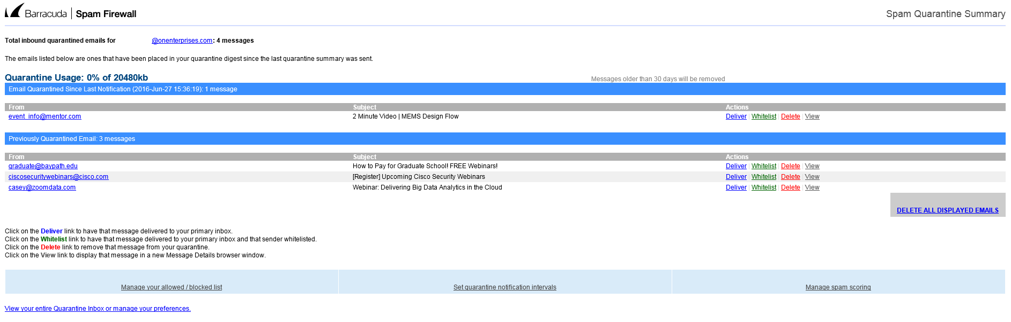

Logging on to the Barracuda Spam Filter
Click the following link: https://mail1.onenterprises.com

In the username field enter your full email address.

In the password field enter your barracuda password.

Click the Login button.

If you cannot remember your Barracuda password or need to create a Barracuda password; click on the Create New Password box and follow the instructions.

Spam Quarantine Interface

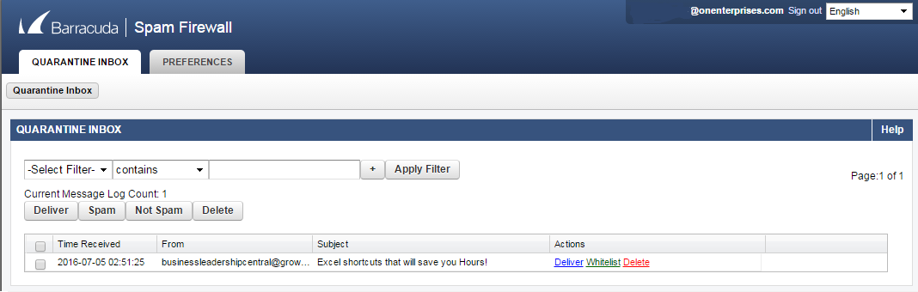

Whitelist and Blacklist Definitions
Whitelist | The list of email addresses from which you always wish to receive messages. The only time the Barracuda Spam Filter blocks a message from someone on your whitelist is when the message contains a virus or a disallowed attachment file extension.
Blacklist | The list of senders from whom you never want to receive messages. The Barracuda  Spam Filter immediately deletes messages from senders on your blacklist. These messages are not tagged or quarantined and cannot be recovered. The sender does not receive a notice that the message was deleted, and neither do you. The only time a blacklisted email address is delivered is if the same email address also appears in your whitelist.

